Gradient Boost for Regression: Detailed Notes
Gradient Boost is a powerful machine learning algorithm used for both regression and classification tasks. This video focuses on its application for regression, where the goal is to predict a continuous value (e.g., weight, price, temperature).

Core Idea: Iterative Improvement with Small Steps 🚀
The fundamental concept behind Gradient Boost is to iteratively build a model by taking "small steps in the right direction." Instead of building one complex, powerful model, it builds many simple, weak models (decision trees) sequentially. Each new tree focuses on correcting the errors made by the previous trees.

Comparison with AdaBoost 🆚
Before diving into Gradient Boost, the video briefly compares it to AdaBoost, another boosting algorithm:
Feature | AdaBoost | Gradient Boost
Initial Step | Builds a short tree (stump) | Starts with a single leaf (average value)
Tree Size | Primarily uses "stumps" (very short trees) | Uses larger trees (e.g., 4-32 leaves), but restricted
Scaling Trees | Scales each stump's contribution based on its performance (how well it compensated for previous errors) | Scales all trees by the same amount using a learning rate
Focus | Builds new stumps based on errors of the previous stump | Builds new trees based on residuals (errors) of the previous combined predictions
Export to Sheets

Step-by-Step Walkthrough with an Example (Predicting Weight)
Let's use the example from the video: predicting a person's weight based on their height, favorite color, and gender.
- Initial Prediction: The Average Weight (The First "Leaf")
  - Gradient Boost begins by making a single initial prediction for all samples.
  - For regression, this first prediction is always the average value of the variable you are trying to predict (the target variable) from your training data.
  - Example: If the observed weights are [88, 77, 65, 78, 55, 68] kg, the average weight is (88 + 77 + 65 + 78 + 55 + 68) / 6 = 71.2 kg.
  - Therefore, the initial prediction for everyone's weight is 71.2 kg.
- Calculate the "Pseudo Residuals" (The Errors)
  - After the initial prediction, Gradient Boost doesn't stop. It needs to figure out how wrong its current prediction is for each sample.
  - This "wrongness" is measured by calculating the difference between the observed (actual) value and the current predicted value. These differences are called pseudo residuals.
  - Formula: Pseudo Residual = Observed Value - Current Predicted Value
  - Example:
    - Person 1: Observed = 88 kg, Predicted = 71.2 kg → Residual = 88 - 71.2 = 16.8
    - Person 2: Observed = 77 kg, Predicted = 71.2 kg → Residual = 77 - 71.2 = 5.8
    - ... and so on for all individuals.
  - Note on "Pseudo": The term "pseudo" is a reminder that while similar to residuals in linear regression, this is part of the Gradient Boost process and has a deeper mathematical basis (which will be covered in Part 2 of the series).
- Build a Decision Tree to Predict the Pseudo Residuals
  - Instead of directly predicting the original weight, the next step is to build a new decision tree whose goal is to predict the pseudo residuals calculated in step 2.
  - This tree uses the same input features (height, favorite color, gender) as before.
  - Tree Size Restriction: Gradient Boost typically restricts the size of these trees to prevent overfitting. In the video's simple example, trees are limited to a maximum of 4 leaves. In practice, this can range from 8 to 32 leaves.
  - Averaging Residuals in Leaves: If multiple data points end up in the same leaf of the decision tree, their individual pseudo residuals within that leaf are replaced by the average of those residuals.
    - Example: If two people both have a residual of -16.2 and another of -18.2 in the same leaf, their new "predicted residual" for that leaf becomes (-16.2 + -18.2) / 2 = -17.2.
- Combine Predictions with a Learning Rate
  - Now, we combine the initial prediction (the average weight) with the output of the new decision tree.
  - However, to prevent overfitting and ensure that each tree takes only a "small step" towards the correct answer, Gradient Boost introduces a learning rate (also known as shrinkage).
  - Learning Rate (η): A value between 0 and 1 (commonly set to 0.1). It scales the contribution of each new tree.
  - Formula for New Prediction: New Predicted Value = Previous Predicted Value + (Learning Rate × Output of New Tree)
  - Example:
    - Initial Prediction = 71.2
    - Output of New Tree (predicted residual for a specific person) = 16.8
    - Learning Rate = 0.1
    - New Predicted Weight = 71.2 + (0.1 × 16.8) = 72.9
  - Why a Learning Rate? Taking many small steps (with a small learning rate) in the right direction generally leads to better generalization on unseen testing data (lower variance) compared to taking one giant step that perfectly fits the training data but might not perform well on new data.
- Iterate: Repeat Steps 2-4 (Build More Trees)
  - The process is repeated.
  - Recalculate Pseudo Residuals: New pseudo residuals are calculated based on the latest combined predictions (e.g., 72.9 kg from the previous step) and the observed weights. These new residuals will be smaller than the previous ones, indicating progress.
  - Build Another Tree: A new decision tree is built to predict these new pseudo residuals.
  - Scale and Add: The output of this new tree is again scaled by the same learning rate and added to the current combined prediction.
  - This cycle continues, with each new tree attempting to correct the remaining errors, until one of two conditions is met:
    - The maximum number of trees (or iterations) specified by the user is reached.
    - Adding additional trees does not significantly reduce the size of the residuals.

Final Prediction
- Once all the trees are built, to make a prediction for a new, unseen data point, you start with the initial average prediction.
- Then, you add the scaled output (scaled by the learning rate) from each of the trees in the sequence.
- Formula: Final Prediction = Initial Average + (η × Tree₁ Output) + (η × Tree₂ Output) + ... + (η × Treeₙ Output)
- This sum gives the final predicted continuous value (e.g., predicted weight).
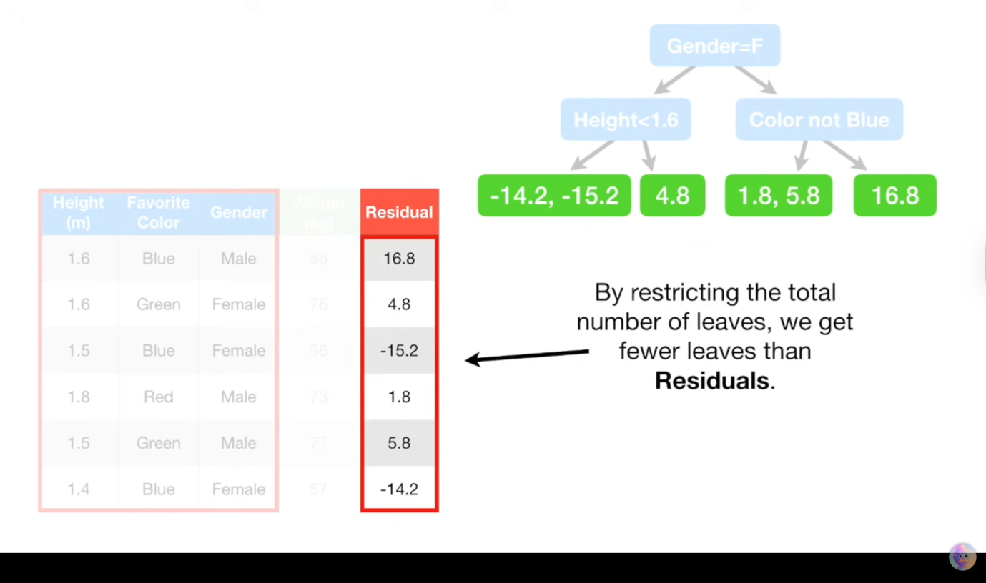
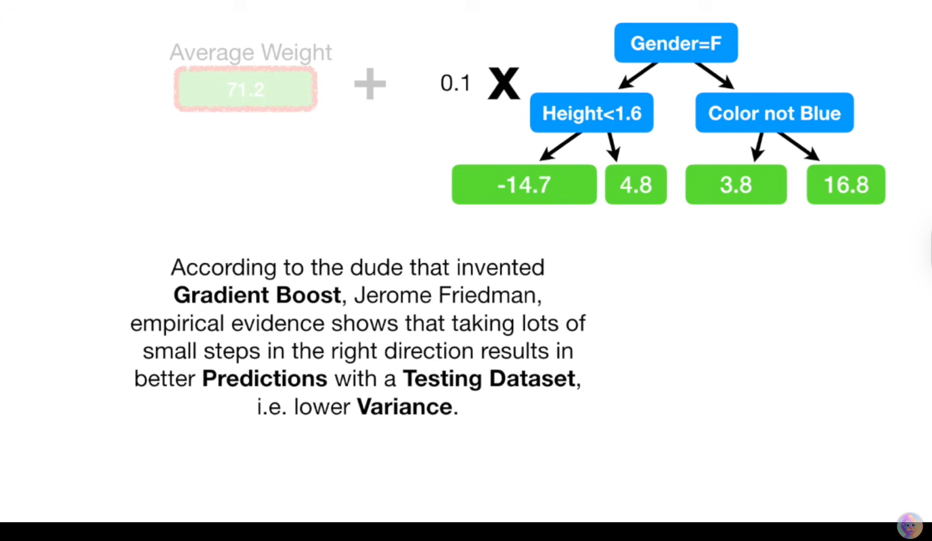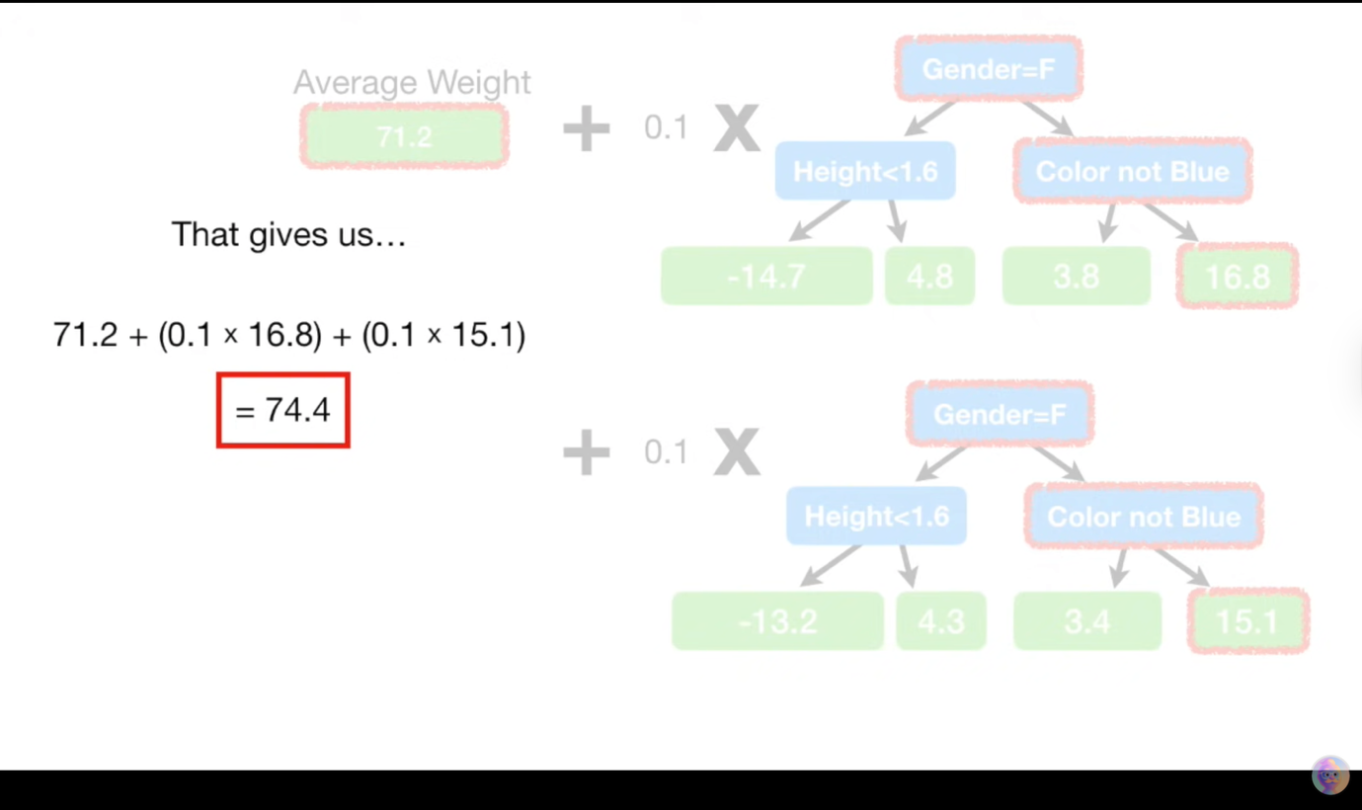

Gradient Boost for Classification: Detailed Notes
The video "Gradient Boost Part 3 (of 4): Classification" by StatQuest with Josh Starmer focuses on how the Gradient Boost machine learning algorithm is adapted for classification tasks. It builds upon the core concepts of Gradient Boost for regression but introduces specific adjustments for handling categorical outcomes.

I. Core Concepts and Distinctions from Regression 🤼
Gradient Boost for classification, like its regression counterpart, iteratively builds an ensemble of weak learners (decision trees) to form a strong predictive model. The key differences lie in how errors are defined and corrected for categorical predictions.
- Objective: To predict a categorical outcome (e.g., "loves Troll 2" vs. "does not love Troll 2") rather than a continuous numeric value.
- Initial Prediction: Instead of the average value, the initial prediction for every individual is the log of the odds of belonging to the positive class. This aligns with the mathematical foundations of logistic regression.
- Pseudo Residuals: While still the "errors" between observed and predicted values, their calculation is specific to the probability domain of classification.
- Leaf Output Values: The method for calculating the contribution of each leaf in the decision trees is specialized for classification to operate in the log-odds space.
- Learning Rate (Shrinkage): Remains crucial to control the step size of each new tree's contribution, preventing overfitting by taking "small steps in the right direction."

II. Step-by-Step Process for Classification 🧑‍🏫
Let's illustrate the process using the video's example: predicting whether someone "Loves the movie Troll 2" based on features like popcorn preference, age, and favorite color.
- Initial Prediction: Log of the Odds 🎲
  - Purpose: To establish a baseline prediction for all individuals.
  - Method: Calculate the overall log of the odds for the positive class (e.g., "loves Troll 2") from the training data.
    - Odds = (Number of "Yes" outcomes) / (Number of "No" outcomes)
    - Log Odds = ln(Odds) (natural logarithm)
  - Example: If 4 people love Troll 2 and 2 don't:
    - Odds = 4 / 2 = 2
    - Log Odds = ln(2) ≈ 0.6931 (video rounds to 0.7)
  - This initial log-odds value (e.g., 0.7) becomes the first prediction for every individual.
- Convert Log Odds to Probability ➡️ P
  - Purpose: To make the log-odds interpretable as a probability for classification and error calculation.
  - Method: Use the logistic (sigmoid) function to transform the log-odds into a probability between 0 and 1.
    - Probability (P) = e^(Log Odds) / (1 + e^(Log Odds))
  - Example: For initial Log Odds of 0.6931:
    - P = e^(0.6931) / (1 + e^(0.6931)) = 2 / (1 + 2) = 2 / 3 ≈ 0.6667 (video uses 0.7 due to rounding).
  - Initial Classification: Based on this probability (e.g., 0.6667 > 0.5 threshold), everyone is initially classified as "loves Troll 2."
- Calculate Pseudo Residuals (Errors) 📉
  - Purpose: To quantify how "wrong" the current model's predictions are for each sample, providing targets for the next tree.
  - Method: The residual for classification is the difference between the observed probability (0 or 1) and the current predicted probability.
    - Residual = Observed Probability - Predicted Probability
  - Example:
    - For someone who loves Troll 2 (Observed = 1), and Predicted P = 0.6667: Residual = 1 - 0.6667 ≈ 0.3333.
    - For someone who does not love Troll 2 (Observed = 0), and Predicted P = 0.6667: Residual = 0 - 0.6667 ≈ -0.6667.
  - These residuals become the new "target variable" for the next decision tree.
- Build a Decision Tree to Predict Residuals 🌳
  - Purpose: To create a weak learner that identifies patterns in the errors made by the current ensemble.
  - Method: A decision tree is built using the input features (e.g., popcorn preference, age, favorite color) to predict the pseudo residuals calculated in step 3.
  - Tree Size: The tree's complexity is usually restricted (e.g., max_leaves between 8 and 32 in practice; 3 leaves in the video's simple example) to keep it a "weak" learner and prevent overfitting.
- Calculate Leaf Output Values (Specialized Formula) 🍁
  - Purpose: To convert the residuals within each leaf into a suitable "step size" in the log-odds domain. This is not a simple average of residuals as in regression.
  - Method: For each leaf, the output value is calculated as: Leaf Output = (Sum of Residuals in Leaf) / [Sum of (P_i * (1 - P_i)) for all samples i in Leaf]
    - Where P_i is the Previous Predicted Probability for sample i before the current tree was added.
  - Example:
    - Leaf with one sample: If a leaf has one sample with Residual = -0.6667 and P_i = 0.6667:
      - Output = -0.6667 / (0.6667 * (1 - 0.6667)) = -0.6667 / (0.6667 * 0.3333) ≈ -3.0.
    - Leaf with multiple samples: The sums are performed for all samples within that leaf.
  - These leaf outputs are in the log-odds space.
- Update Log Odds Prediction with Learning Rate ⬆️
  - Purpose: To incrementally refine the overall prediction, taking a cautious step based on the new tree's insights.
  - Method: The New Log Odds prediction is calculated by adding the Previous Log Odds prediction to the Leaf Output, scaled by a learning rate (η).
    - New Log Odds = Previous Log Odds + (Learning Rate × Leaf Output)
    - Learning Rate (η): A value between 0 and 1 (e.g., 0.1 is common; 0.8 is used in the video for clearer illustration). It controls the step size.
  - Example:
    - Previous Log Odds = 0.7, Leaf Output = 1.4, Learning Rate = 0.8
    - New Log Odds = 0.7 + (0.8 × 1.4) = 0.7 + 1.12 = 1.82.
  - This new log-odds value represents an updated prediction for the individual.
- Convert New Log Odds to New Probability 🔄 P
  - Purpose: To see the updated prediction as an interpretable probability.
  - Method: Apply the logistic (sigmoid) function to the New Log Odds.
  - Example: For New Log Odds = 1.82:
    - P = e^(1.82) / (1 + e^(1.82)) ≈ 0.861 (video rounds to 0.9).
- Iterate: Recalculate and Repeat 🔁
  - Steps 3-7 are repeated for a predetermined number of iterations (trees) or until the residuals become negligibly small.
  - In each subsequent iteration, the "Previous Predicted Probability" used in the leaf output formula (Step 5) will be the individualized probability calculated in the last iteration (Step 7). This allows the model to adapt its focus to the remaining errors of the evolving ensemble.

III. Making a Final Classification ✅
Once all trees are built:
- Cumulative Log Odds: For a new data point, start with the initial overall Log Odds.
- Add Scaled Tree Outputs: Run the data through each trained tree sequentially. Add the scaled output value (leaf output × learning rate) from each tree's respective leaf to the cumulative Log Odds.
  - Final Log Odds = Initial Log Odds + (η × Tree₁ Output) + (η × Tree₂ Output) + ... + (η × Treeₙ Output)
- Final Probability: Convert the Final Log Odds into a Final Probability using the logistic function.
- Classification: Apply a classification threshold (e.g., 0.5) to the Final Probability to get the final categorical prediction.
  - Example: If Final Log Odds = 2.3 (from the video), then Final Probability = e^(2.3) / (1 + e^(2.3)) ≈ 0.9. With a 0.5 threshold, this classifies the person as "loves Troll 2."

IV. Practical Considerations for Data Science Interviews 🧠
- Computational Cost: Be aware that Gradient Boost can be computationally expensive due to its sequential nature and the need to calculate residuals at each step.
- Hyperparameter Tuning: Crucial for performance. Key hyperparameters include:
  - n_estimators: Number of trees (iterations).
  - learning_rate: Step size for each tree's contribution.
  - max_depth: Maximum depth of individual trees (controlling their complexity and preventing overfitting).
  - min_samples_leaf: Minimum samples required to be at a leaf node.
- Overfitting: Gradient Boost is powerful but can overfit if not properly regularized (e.g., too many trees, too high a learning rate, too deep trees). Techniques like early stopping, setting max_depth, and using a small learning_rate are essential.
- Loss Function: Gradient Boost is flexible and can optimize different loss functions. For classification, it implicitly optimizes a loss function related to logistic regression (like log-loss or cross-entropy).
- Ensemble Power: Emphasize that the strength of Gradient Boost comes from combining many weak, imperfect models into a highly accurate and robust predictor.

